CSE 3002 – INTERNET AND WEB PROGRAMMING
DHRUBANKA DUTTA – 17BCE1019
L – 43,44
PHP FILES AND XML
FACULTY : DR. SANDHYA P

Q1: PHP FILES

<!DOCTYPE html>
<html>
<body>
<form action="" method="POST">
<table>
<tr>
<td> Enter the location of the file to be copied </td> <td> <input type='text' name ='file1'> </td>
</tr>
<tr>
<td> Enter the location of the copied file </td> <td> <input type='text' name = 'file2'> </td>
</tr>
</table>
<input type='submit' name='submit'>
</form>
</body>
</html>
<?php
if(isset($_POST['submit']))
{
$myfile = fopen($_POST['file1'],"r");
$myfile2 = fopen($_POST['file2'],"w+");
$content = fread($myfile,filesize($_POST['file1']));
$var = fclose($myfile);
fwrite($myfile2,$content);
fclose($myfile2);
if($var)
{
echo "File Successfully Copied";
}
}
?>
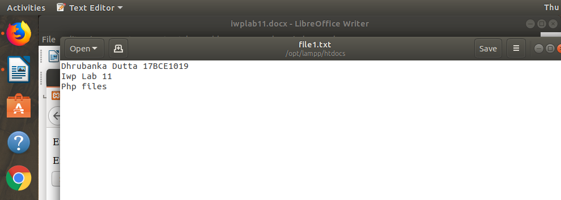
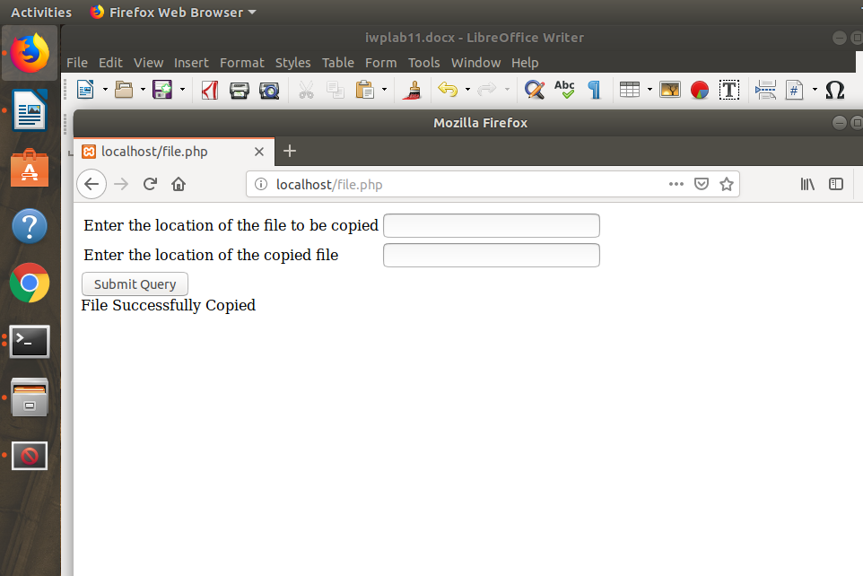

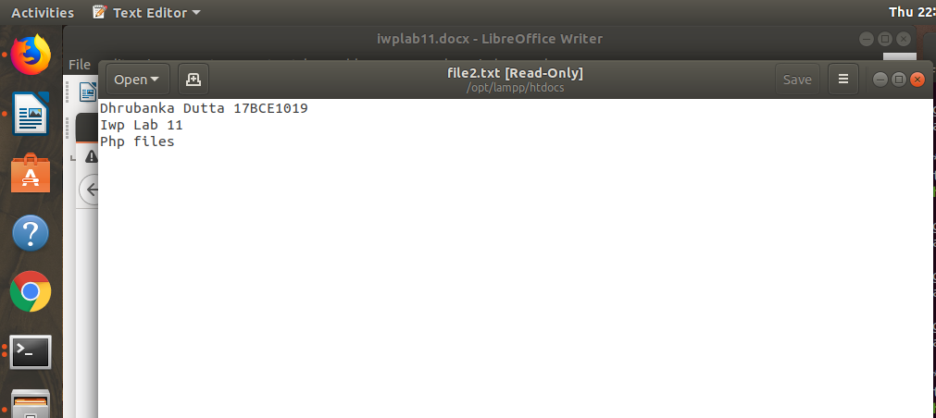

Q2: XML FILE

<?xml version='1.0' encoding='UTF-8'?>
<definitions xmlns:s="http://www.w3.org/2001/XMLSchema">
<key name='student' regno='17BC1019'>
<name>
<first_name>Dhrubanka</first_name>
<last_name>Dutta</last_name>
</name>
<age>19</age>
<graduate>ug</graduate>
<program>btech</program>
<degree>
<s:enumeration value="CS" />
<s:enumeration value="ECE" />
<s:enumeration value="IT" />
</degree>
</key>
</definitions>

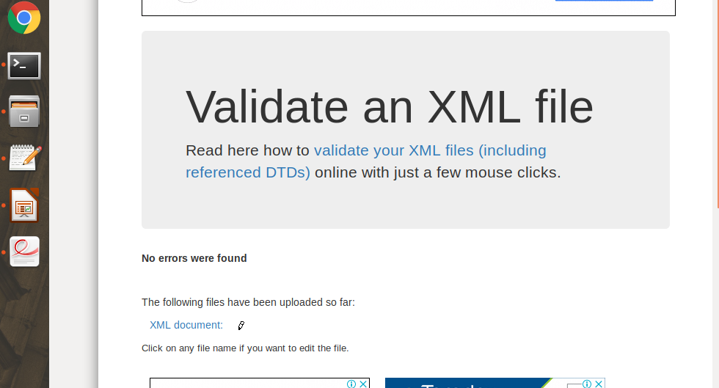
INTERNAL VALIDATION :

EXTERNAL VALIDATION :



